

**Excel Assignment - 7**

1. Using Insert Function, give examples of any function available in the different dropdowns present in the function library. For example AutoSum, Recently Used, Text, Date & Time, etc.

Answer: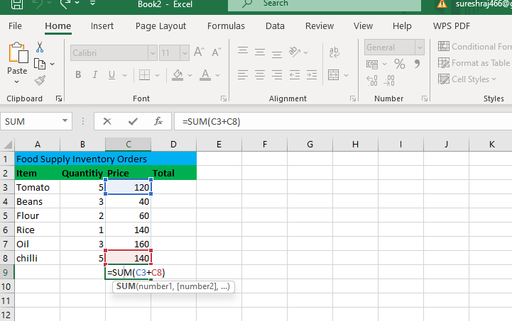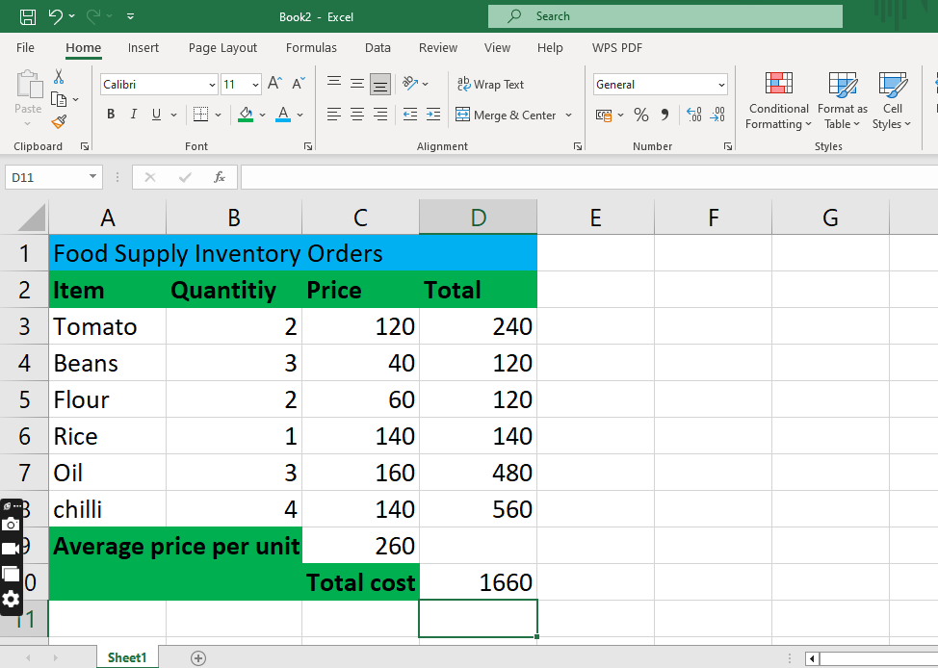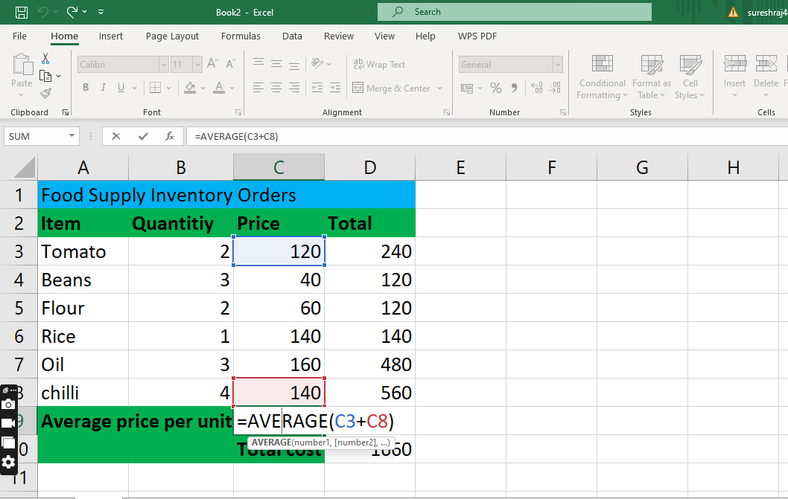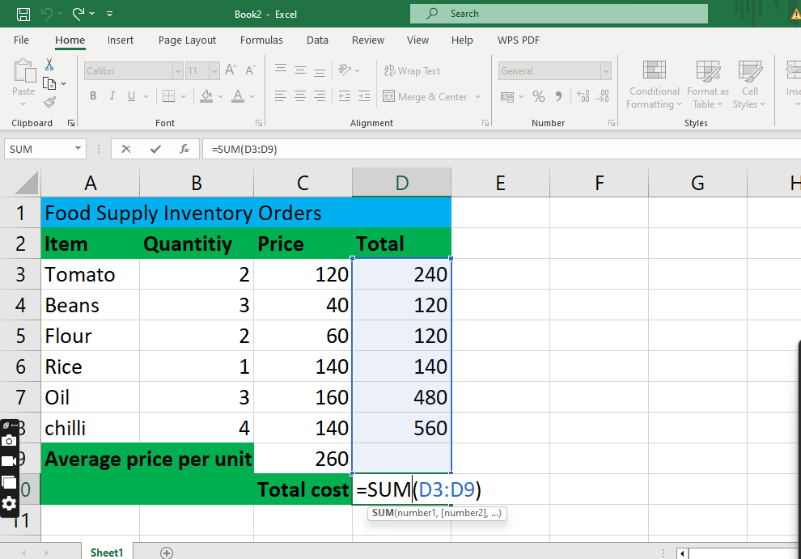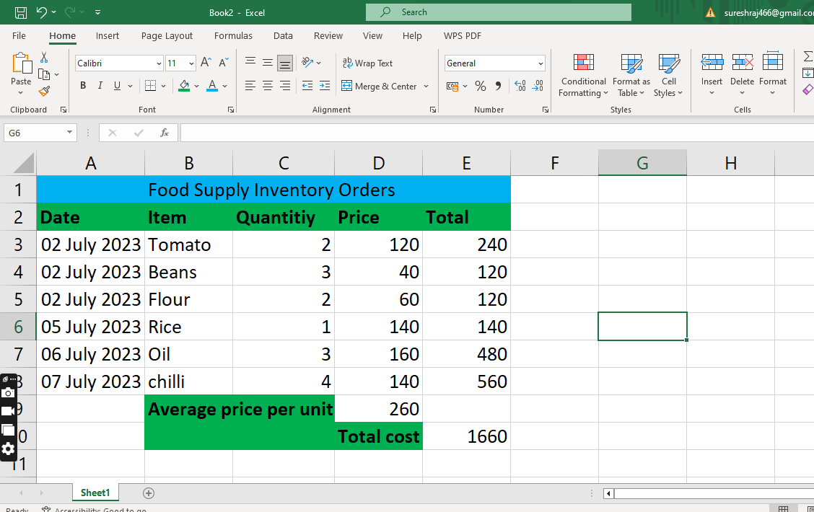

2. What are the different ways you can select columns and rows?

Answer:

## Select one or more cells

1. Click on a cell to select it. Or use the keyboard to navigate to it and select it.
2. To select a range, select a cell, then with the left mouse button pressed, drag over the other cells.  
   Or use the Shift + arrow keys to select the range.
3. To select non-adjacent cells and cell ranges, hold Ctrl and select the cells.

## Select one or more rows and columns

1. Select the letter at the top to select the entire column. Or click on any cell in the column and then press Ctrl + Space.
2. Select the row number to select the entire row. Or click on any cell in the row and then press Shift + Space.
3. To select non-adjacent rows or columns, hold Ctrl and select the row or column numbers.

## Select table, list or worksheet

1. To select a list or table, select a cell in the list or table and press Ctrl + A.
2. To select the entire worksheet, click the **Select All** button at the top left corner.

3. What is AutoFit and why do we use it?

Answer: AutoFit is a feature in Excel that allows you to quickly [adjust the row height](https://trumpexcel.com/change-row-height-excel/) or column width to fit the text completely (so that there is no spilling over to other cells).

Also, AutoFit means that you don’t have to manually specify the column width or row height (or manually drag and adjust the column width). It’s Auto- i.e., it will figure out itself how much it should expand/contract to fit the current cell content

* **AutoFit Column Width**: This feature automatically adjusts the column width to fit the text in the cell. You can fit text for multiple columns at once (as we will see later in examples)
* **Autofit Row Height**: This feature automatically adjusts the row height to fit the text in the cell. You can autofit multiple rows at once.

In most cases, you would notice that Excel automatically adjusts the row height when you enter more than one line in the same cell. In those cases, you won’t need to do any row height adjustment.

But sometimes, you may get a dataset from someone or as a download, where row height has already been fixed and needs adjustment. You can use the ‘AutoFit Row Height’ feature in that case.

1. Using the mouse double-click method
2. Using the AutoFit option in the ribbon
3. Using a keyboard shortcut

All these methods work fine and you can choose whichever works best for you.

4. How can you insert new rows and columns into the existing table?

Answer: we can add a row above or below the cursor position.

1. Click where you want in your table to add a row or column and then click the **Layout** tab (this is the tab next to the **Table Design** tab on the ribbon).
2. To add rows, click **Insert Above** or **Insert Below** and to add columns, click **Insert Left** or **Insert Right**.

5. How do you hide and unhide columns in excel?

Answer: Under **Visibility**, click **Hide & Unhide**, and then click **Unhide Rows** or **Unhide Columns**.

* Under **Cell Size**, click **Row Height** or **Column Width**, and then in the **Row Height** or **Column Width** box, type the value that you want to use for the row height or column width.



6. Create an appropriate table within the worksheet and use different functions available in the AutoSum command.

Answer: 